CASA0011 Coursework 2
Investigating The Holborn Escalator Paradox
An Agent-Based Model of Walking vs Standing Throughput
on London Underground Escalators

2026-04-01

Declaration of Authorship

Student Number: 25049107
Word Count: 1,085 words

I, Tee Chin Min Benjamin, pledge my honour that the work presented in this assessment is my own. Where information has been derived from other sources, I confirm that this has been indicated in the work. AI generators (ChatGPT and Claude) were used to develop ideas for the coursework as well as refining and improving the NetLogo code for agent behaviour.

1. ODD Description

1.1 Purpose and Patterns
This model investigates the “Holborn escalator paradox”, the counterintuitive finding that prohibiting walking on escalators increases overall throughput during peak hour.
Primary research question:
How does the proportion of walking versus standing commuters affect escalator throughput, and under what conditions does a standing-only policy outperform a mixed-behaviour regime?
Subsidiary questions:
- How does the ratio of walking to standing commuters affect total throughput (passengers per minute)?
- How does lane-switching discipline affect performance during periods of congestion?
We evaluate the model on its ability to reproduce two empirical patterns. First, throughput inversion documented during Transport for London’s 2015–2016 standing trial at Holborn station, where a standing-only policy on a long escalator increased capacity by approximately 30% during peak hours. Second, queue formation asymmetry where queues form disproportionately in the waiting area because of limited lane availability, while the walking lane has unused capacity.

1.2 Entities, State Variables, and Scales
Entities
- Commuters (turtles) represent travellers arriving via the Underground.
- Environment (patches) mirror train station infrastructure. Patch types include spawn (entrance), concourse (waiting area), marshalling area (agents jostle to board), escalator-steps, and an exit zone.
Agent state variables
Variable | Type/Range | Description
walk-preference | [0, 1] | Base probability of preference to walk or stand on the escalator
is-walking? | Boolean | Current behaviour state: walking or standing
walk-speed | [0, 1] | Actualized probability of taking an extra step per tick. 0 for standers and inherits the walk-probability value for walkers.
walk-probability | [0, 100] | Global parameter defining the "cadence" of walkers, representing the likelihood that a walker will move an additional patch beyond the escalator's mechanical movement in a single tick.
preferred-lane-x | Integer {0, 1} | x-coordinate of the agent's target lane. 0 for Left (Standing), 1 for Right (Walking).
blocked-ticks | Integer ≥ 0 | Consecutive ticks the agent has been unable to advance; used to trigger lane-switching via the lane-discipline threshold.
arrival-tick | Integer ≥ 0 | The tick at which the agent was added to the demand-pool, used to calculate total station time.
agent-state | String | "Approaching" | "queueing" | "On-escalator"

Patch state variables
Variable | Type/Range | Description
Patch-type | String | "escalator-left" | "escalator-right" | “boundary rails” | "concourse" | "marshalling" | "background" | "exit-zone" | "spawn"
Is-step? | Boolean | True if the patch is part of the escalator belt; used to validate movement logic.
step-number | Integer ≥ 0 | The vertical index (e.g. 0–59) of the step relative to the escalator-bottom-y.
dist-to-escalator | Integer 0 | Dijkstra cost value calculated during setup; represents the shortest path distance to the escalator entrance.
path-selected? | Boolean | A temporary flag used during the Dijkstra computation to track which patches have been visited.

Scales
Spatial Scale: Each patch represents ~0.4 meters (standard escalator step).
Temporal Scale: Each tick corresponds to 0.533 seconds.
Speed Conversion:
- Mechanical Speed: Escalator is calibrated to move at rate of 1 patch per tick (1 patch = 0.4m, 1 tick = 0.533s) or 0.75 m/s, the standard operating speed for London Underground escalators.
- Behavioural Speed: Walk-probability allows for the emergence of varied walking speeds relative to moving steps.
  - 100% walk-probability agents move 2 patches per tick (1.5 m/s)
  - 50% walk-probability agents move an average of 1.5 patches per tick (1.13 m/s). This stochastic approach allows for small, random variations in movement which more accurately reflects human gait variations.

1.3 Process Overview and Scheduling
The simulation runs for 13,560 ticks (120 minutes at 113 ticks/min), comprising a 30-minute warm-up, 60-minute rush hour (08:30–09:30), and 30-minute cool-down. Five submodels execute sequentially each tick:
- Arrival (submodel-arrival): During rush hour, commuters arrive via train batch to a demand pool at fixed intervals. Agents drain into spawn patches (30 pax/tick), modelling platform exit bottlenecks. Each agent receives a walker/stander type and preferred lane based on pct-walkers. Arrival timestamps are added to calculate end-to-end wait-time. Off-peak, agents arrive at rate of 20 per minute.

- Approach (submodel-approach): Agents follow a channel-based distance field toward the escalator. Directional penalty terms in two Euclidean cost surfaces create angled corridors, separating standers leftward and walkers rightward. Agents use 8-connected movement and transition to "queueing" upon entering the marshalling zone.

- Boarding (submodel-boarding): Queued agents, sorted by proximity then FIFO, attempt their preferred lane. Boarding requires the bottom N steps to be empty (N = step-gap-stand or step-gap-walk). Under mixed policy, lane discipline prevents lane-switching until a threshold is exceeded. Under standing-only, both lanes are used freely.

- Movement (submodel-movement): The escalator advances all agents 1 patch/tick, processed top-to-bottom. Walkers attempt one probabilistic extra step. Agents are only blocked by same-lane occupants ahead.

- Exit (submodel-exit): Agents at the top are counted, journey time recorded, and removed.

Thereafter, the model updates global counters, including per-minute throughput and mean travel times. All transitions are synchronous within each sub-model.

1.5 Initialisation

Upon setup, two escalator lanes (x=0 standing, x=1 walking) spanning 60 steps vertically, flanked by boundary rails are created. A tapered marshalling zone (4 rows) funnels agents toward the entrance. A 25-patch concourse and 10-row spawn zone represent the station. The channel-based distance field is computed at setup.

Default parameters are set using sliders.
Variable | Default Values | Range
pct-walkers | 40% | 0 – 100%
escalator-length | 60 steps | 20 – 60 steps
batch-size | 220 persons | 100 – 300 persons
train-interval | 2.0 min | 1.0 – 3.0 min
step-gap-stand | 2 steps | 1 – 4 steps
step-gap-walk | 3 steps | 1 – 4 steps
walk-probability | 66% | 0 – 100%
lane-discipline | 120s | 0 – 300s
off-peak-rate | 20 persons / min | 10 – 30 persons / min

1.6 Input Data
The model does not use external data files. Escalator geometry was derived from London Underground specifications (0.4m step depth, 0.75 m/s speed, ~24m height, yielding 1 tick = 0.533s). Throughput benchmarks draw from TfL's Holborn pilot report where counter data showed ~80 pax/min per escalator at peak, with standing-only carrying ~3,250 versus ~2,550 under mixed behaviour during 08:30–09:30. Train headway data (2–3 min intervals across Piccadilly and Central lines) informed batch arrival parameterisation.

1.7 Submodels
Figure 1 outlines the sub-models and algorithms in detail.

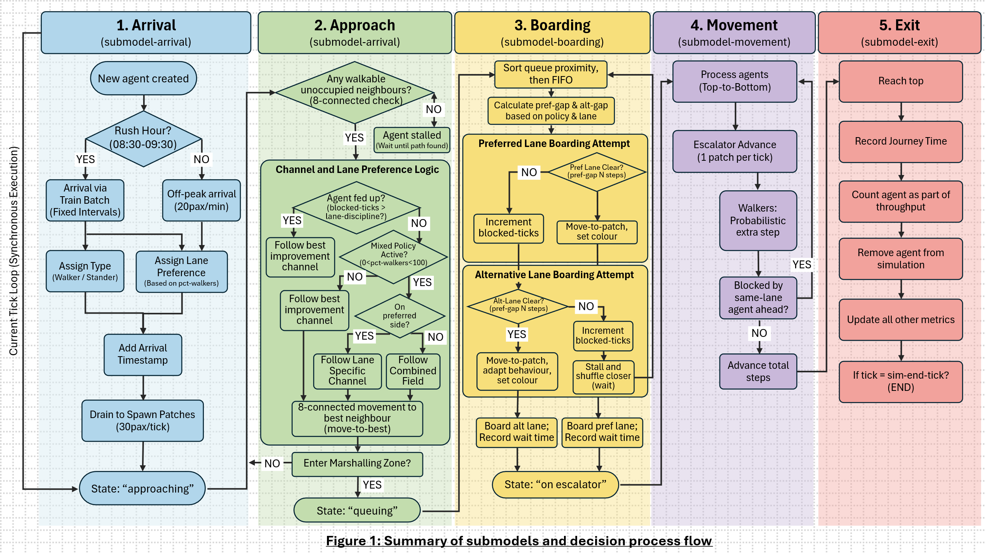
Calibration. The empirical paradox was observed under this parameter set.

Component | Parameter | Value / Description
Demand Calibration | Batch size | 200–240 passengers
 | Train interval | 2 minutes
 | Demand condition | Slightly exceeds escalator capacity to induce queue build-up
Escalator Dynamics | Step-gap (standing) | 2 steps per person ~56.5 pax/min/lane
 | Step-gap (walking) | 3 steps per person ~37.7 pax/min/lane
 | Lane discipline | 120s to mirror social norming and allow for a denser standing lane relative to walking lane.

Further BehaviorSpace experiments were run with 5 iterations and different random seeds and simple average for key output variables was computed.

- Overall, the mixed regime performs worst, confirming the paradox (Figure 2). Standing-only conditions (0% walkers) maximise throughput at ~110 pax/min, as both lanes are fully utilised. In mixed conditions (40% walkers), lane discipline concentrates demand into one standing lane while the walking lane is underused, reducing throughput to ~95 pax/min, the lowest observed. At 100% walkers, both lanes are used again, but larger step-gaps for walking caps throughput at ~104 pax/min.

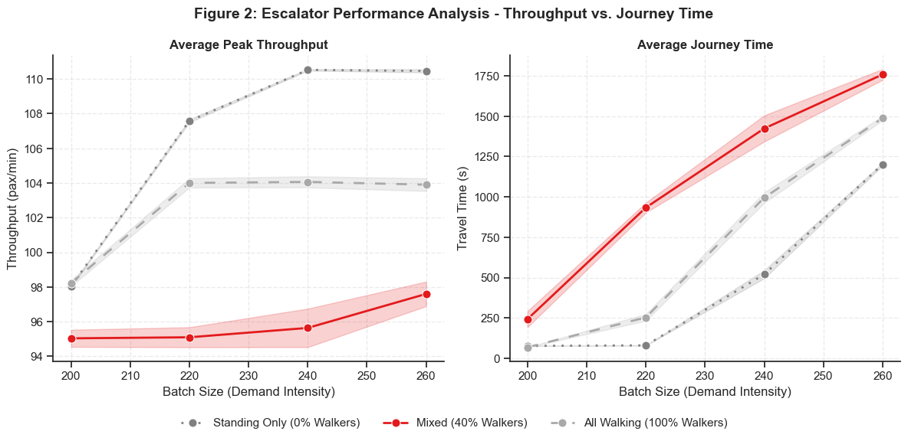
Figure 2: Escalator Performance Analysis – Throughput vs Journey Time

- Lane discipline is the mechanistic driver of the paradox (Figure 3). At low thresholds (30s), standers switch lanes to redistribute demand, achieving throughput near standing-only levels (~104 pax/min). However, high discipline (300s) prevents lane-switching despite congestion, causing throughput to fall 14% (~93 pax/min) and travel times to exceed 16 minutes. Since performance for standing-only and all-walking remains invariant, the paradox arises from asymmetric utilization dictated by social norms rather than walking itself. This suggests that TfL’s policy succeeds by eliminating the norm that prevents standers from using both lanes, not by eliminating walking itself.
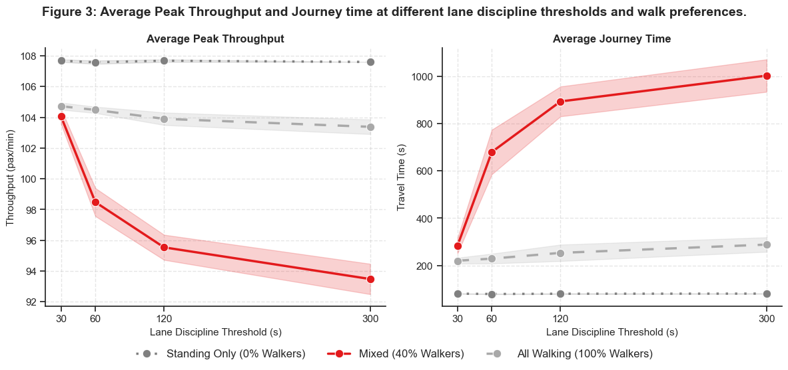
Figure 3: Average Peak Throughput and Journey times at different lane discipline thresholds

2. Situation of Model Within the Literature
This model sits at the intersection of pedestrian flow simulation and cellular automata (CA) approaches to model collective behaviour. It builds on foundational CA pedestrian models by Blue & Adler (2001) and Burstedde et al. (2001), which show that simple, rule-based movement on grids can reproduce realistic crowd dynamics. Methods used in evacuation studies by Galea et al. (2018) and Filippidis et al. (2025) were adapted to construct a two-lane escalator with unidirectional flow and mechanical movement.

Empirically, the model is motivated by TfL’s Holborn trial, where standing-only escalators increased peak throughput by ~30% (Harrison et al., 2016). While queueing models typically assume homogeneous agents and steady-state arrivals, this ABM introduces behavioural heterogeneity such as varying walking speeds, lane-discipline and switching, to examine how individual behaviours shape aggregate outcomes.

Throughput emergence is observed from decentralised decision-making, including the observed inversion under mixed behaviour. Agents display individual-maximising objectives by seeking out the shortest route to the escalator given their preferences. Environment sensing occurs via lane-clear checks and a channel-based distance field, while adaptation occurs through patience-driven lane switching, allowing walk and stand composition to evolve endogenously. Stochasticity enters through batch arrivals, spawn-location, agent types, and probabilistic walking.

The model effectively uses floor-field approaches for navigation, incorporates threshold-based norm adherence, and demonstrates how individually rational preferences can generate collectively suboptimal outcomes, echoing classic micro–macro emergence insights (Schelling ,1971).

----

Bibliography

Blue, V.J. and Adler, J.L. (2001) “Cellular automata microsimulation for modeling bi-directional pedestrian walkways,” Transportation Research Part B: Methodological, 35(3), pp. 293–312. Available at: https://doi.org/10.1016/S0191-2615(99)00052-1.

Burstedde, C. et al. (2001) “Simulation of pedestrian dynamics using a 2-dimensional cellular automaton,” Physica A: Statistical Mechanics and its Applications, 295(3–4), pp. 507–525. Available at: https://doi.org/10.1016/S0378-4371(01)00141-8.

Filippidis, L. et al. (2026) “Assessing the impact of rider-only escalator etiquette using agent-based modelling,” Safety Science, 196, p. 107064. Available at: https://doi.org/10.1016/j.ssci.2025.107064.

Harrison, C. et al. (2016) “Report on Holborn Pilot for Standing on Both Sides of Escalators.”

Galea et al. (2016) Investigating the Representation of Merging Behavior at the Floor—Stair Interface in Computer Simulations of Multi-Floor Building Evacuations (2016). Available at: https://doi.org/10.1177/1042391508095092.

Schelling, T.C. (1971) “Dynamic models of segregation†,” The Journal of Mathematical Sociology, 1(2), pp. 143–186. Available at: https://doi.org/10.1080/0022250X.1971.9989794.

